Ms. Jennifer J. Sara
Global Director, Water Global Practice
World Bank Group

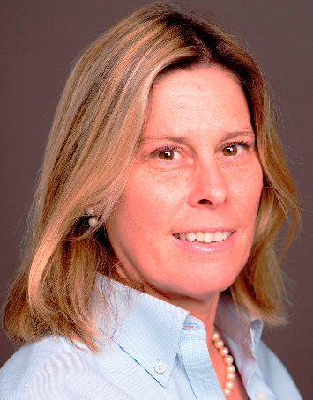
Jennifer Sara is the Global Director for the World Bank Group’s Water Global Practice, taking over this role after four years as Director overseeing operational delivery. Ms. Sara has over 30 years of experience working on global water issues, including overseas assignments in the World Bank as Sector Manager for Sustainable Development based in Hanoi, Vietnam (2010 – 2014); Sector Leader in Brazil (2006 – 2010); and Water and Sanitation Specialist in Bolivia (1990 – 1995). Ms Sara found her passion for water at the start of her career while serving as an intern in the US Indian Health Service and as a Peace Corps Volunteer in Liberia.
In her current assignment, Ms. Sara leads the Practice’s senior management team, which drives the policy direction, oversees a portfolio of $30 billion in water-related investments, analytical work, multi-donor trust funds and global partnerships. She supports an integrated approach to water security with a focus on sustaining water resources, delivering services and building resilience, while recognizing the importance of working across sectors to solve global water challenges, and customizing the Bank’s global water strategy to the country dialogue, and providing policy advice and operational support in response to specific client and community needs.
Ms. Sara holds an MSc in Environmental Management from the University of London, Wye College, and a BSc in Environmental Engineering from Brown University. She also serves as a Governor of the World Water Council, on the International Council of the American Water Works Association and on the International Advisory Committee for the World Wildlife Fund’s Healthy Rivers for All Initiative.

