
Xylem study analyzes life cycle cost of HVAC systems
Hydronic systems outperform VRF, analysis finds

Introduction
Upfront costs and energy consumption are primary drivers when selecting a commercial HVAC system in new and retrofit projects. A new study commissioned by Xylem underscores the importance of evaluating total life cycle cost in the selection process to adequately identify pros and cons of the various system types.

To anecdotally compare and contrast HVAC systems according to their 30-year life cycle cost analysis (LCCA), the Xylem study analyzed seven elementary and middle schools located in South Carolina Climate Zone 3A, a humid, warm climate. The cost analysis includes upfront installed cost, replacement cost allocations and ongoing energy and maintenance cost of the following system types:

- Variable refrigerant flow heat pumps (VRF)
- Water source heat pumps (WSHP)
- Ground source heat pumps (GSHP)
- Direct expansion rooftop units (DX RTU)
- Water cooled chillers (WCC)
- Air-Cooled Chillers (ACC)

With HVAC systems dictating as much as 50 percent of the overall energy use of K-12 buildings, according to ENERGYSTAR, the results of the Xylem study serve to inform decisions and promote maximized energy savings across the commercial construction industry.

Methodology
Over a three-year period, utility cost (electric and natural gas) and average maintenance cost were collected. For a more accurate comparison, construction costs were estimated according to the year each building was built, and utility rates and square footages of these facilities were also normalized to remove any other outside factors. The average electric rate ($k/kWh) and natural gas rate ($/therm) from the sample buildings were multiplied by each building’s electric and natural gas consumption to calculate a normalized energy cost ($/SF) for each building. Each building’s square footage was also considered when calculating maintenance and installation cost.

Findings
From a life cycle cost perspective, the primary drivers of a purely economic decision of all HVAC system types are installation and energy cost. However, these costs are often interrelated with a maintenance department’s unfamiliarity and uncertainty with any given system, eventually showing in the form of increase utility cost from overrides and other changes to the system design.
The study’s findings resulted in the following ranking in life-cycle cost analysis from lowest to highest.
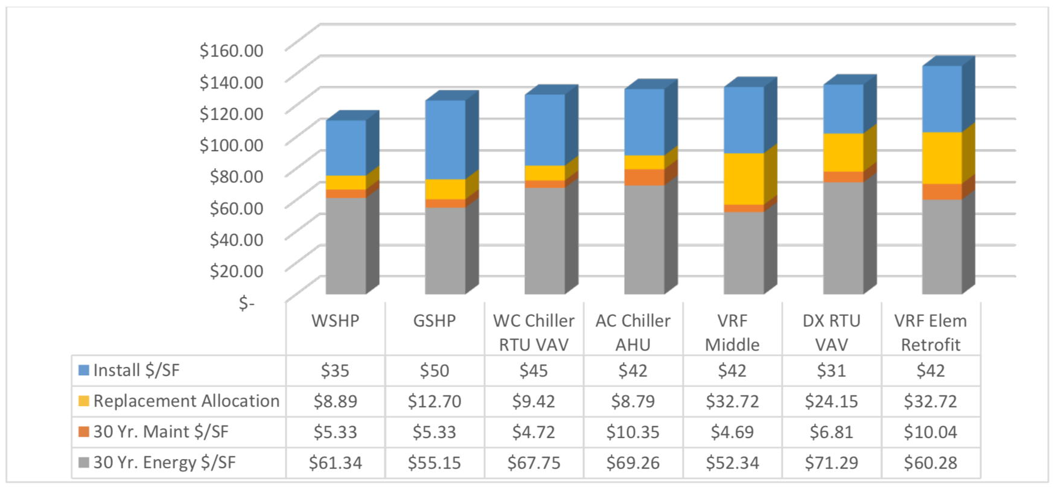
Figure 1

As exhibited in Figure 1, replacement allocations had an impact on the life cycle cost analysis (see yellow bars) and drastically reduced the cost effectiveness of equipment with 15-year life expectancies.
Conclusion
As design engineers, building owners and mechanical contractors strive for more sustainable and energy-efficient practices, these findings shed light on the differences among systems, particularly hydronic and VRF systems. Considerable benefits of hydronic HVAC systems include lower energy usage intensity and cost, wider range of maintenance flexibility and longer life expectancy.

Specifically, the schools with WSHP and GSHP systems displayed energy use levels that were 30 percent (40.7 kBtu/sf) and 41 percent (34.4 kBtu/sf) better than the national median for elementary and middle schools (58.2 kBtu/sf), respectively. The replacement cost allocation also acknowledged that the tested hydronic systems operate effectively for approximately 25 years. The tested VRF systems require replacement a decade earlier because of their tendency to work harder during heating cycles, ultimately bringing proof of long-term cost savings to the forefront of the conversation surrounding sustainability and hydronic HVAC system efficiency.

