
SPECIFICATIONS Domestic Pump Accumulator and
Mechanical Lists in Vacuum Heating System
. . . . . . . . . . . . . . . . . . . . . . . . . . . . . . . . . . . . . . . . . . . . . . . . . . . . . . . . . . . . . . . . . . . . . . . . . . . . . . . . . . . . . . . . . . . . . .

Domestic® Pump Accumulator and
Mechanical Lifts in Vacuum Heating System

Domestic Pump Accumulator Tanks
Condensate return systems should provide unrestricted gravity flow of the condensate and air to a receiver, so that the vacuum differential is more uniformly applied throughout the return system.
In some instances, it may be necessary to drip the returns below the level of a vacuum unit inlet. This can be accomplished by installing a float controlled auxiliary accumulator tank, pitted if necessary, ahead of the vacuum unit inlet. The accumulator tank permits an uninterrupted gravity flow from all return lines. The vacuum on return lines is reduced by 1 inch Hg. for every foot of lift. The lift should be limited to 5 feet. Domestic Pump rectangular cast iron accumulator tanks are shown on drawing IDPD49 and IDPD58. Consult factory for details on underground cast iron accumulator tanks.

Mechanical Lifts
It is often necessary and more practical to use mechanical lifts instead of accumulator tanks. Available for any lift and flow rate, mechanical lifts offer operational cost advantages through direct pumping as compared to the indirect pumping action through a vacuum unit. Domestic Pump condensate units are available for this service but must be specified to incorporate vacuum tight construction. Low cost Domestic Series SCTM Condaflo® condensate units (Section 210), are particularly suited for this application. The application of mechanical lifts is illustrated on drawing IDPD48. Both of the methods shown on this drawing assume that the returns are below floor level. Method No. 2, using a floor mounted condensate unit, is recommended when the vacuum unit is situated at a higher elevation. Method No. 1, the underground condensate unit, is sometimes more practical because it eliminates expensive pit construction and cost of sump pumps, when returns are below floor level.

Improved Mechanical Lifts
Drawing IDPD47 illustrates an efficient and economical method of handling condensate in a vacuum heating system without double pumping. Condensate units may be conveniently installed at several locations and combined with a Domestic Series MJTM Vacuum Unit. All condensate units discharge into the same discharge line, which may be directly connected to a boiler or a Domestic boiler feed unit. Refer to Series VCLTM section 340 for further information and selection of components.

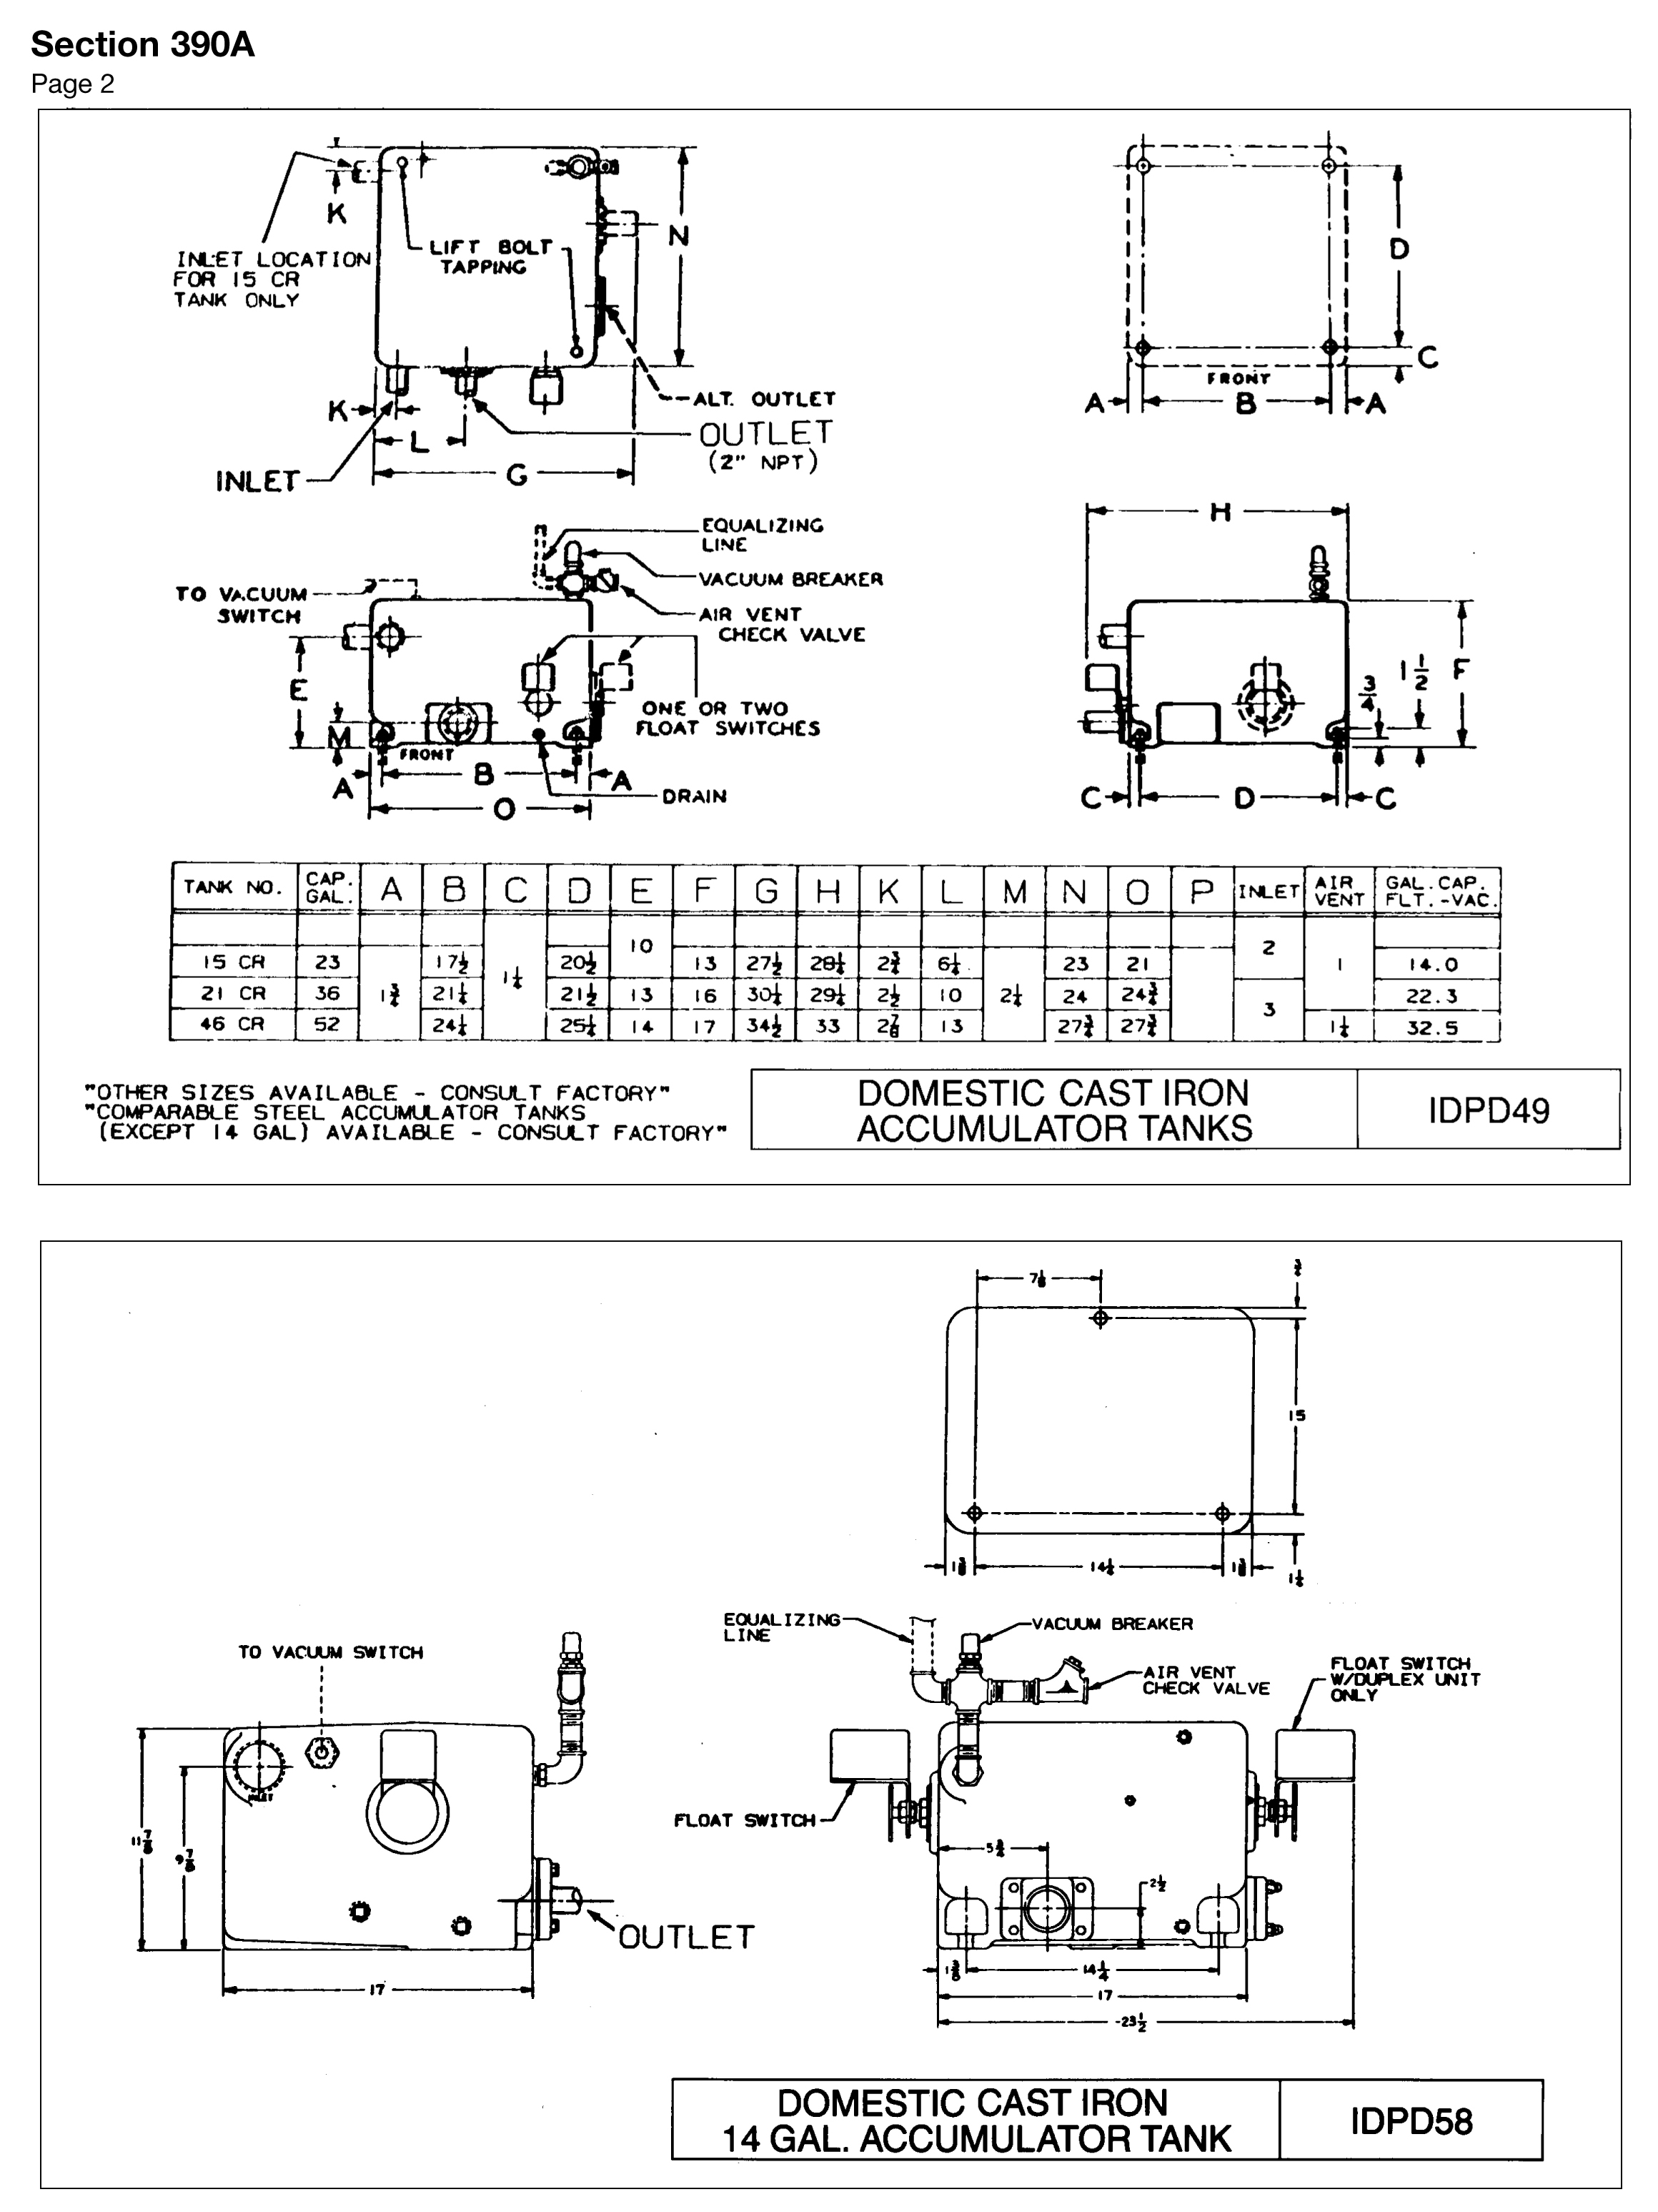
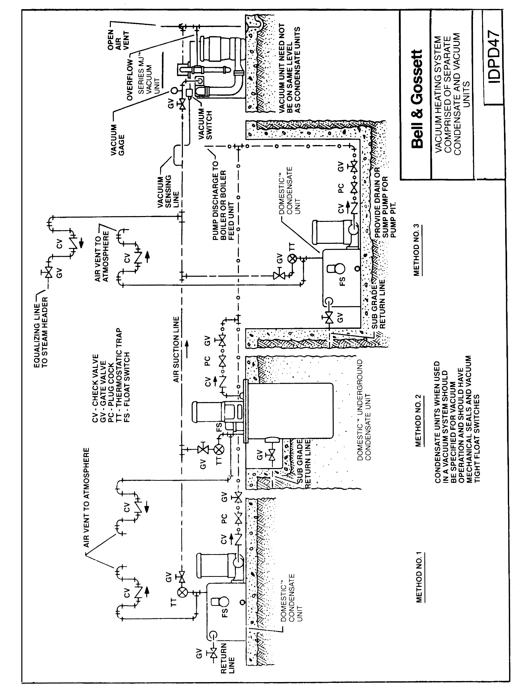

www.bellgossett.com
Bell & Gossett is a trademark of Xylem Inc. or one of its subsidiaries.
© 2016 Xylem Inc. Domestic Pump Acumulator and Mechanical Lifts in Vacuum Heating System Specifications

