
SPECIFICATIONS HS-CSFM-982

. . . . . . . . . . . . . . . . . . . . . . . . . . . . . . . . . . . . . . . . . . . . . . . . . . . . . . . . . . . . . . . . . . . . . . . . . . . . . . . . . . . . . . . . . . . . . .
Circuit Sensor® Flow Meter

Unrestricted lengths of straight piping
Required to maintain calibrated accuracy®


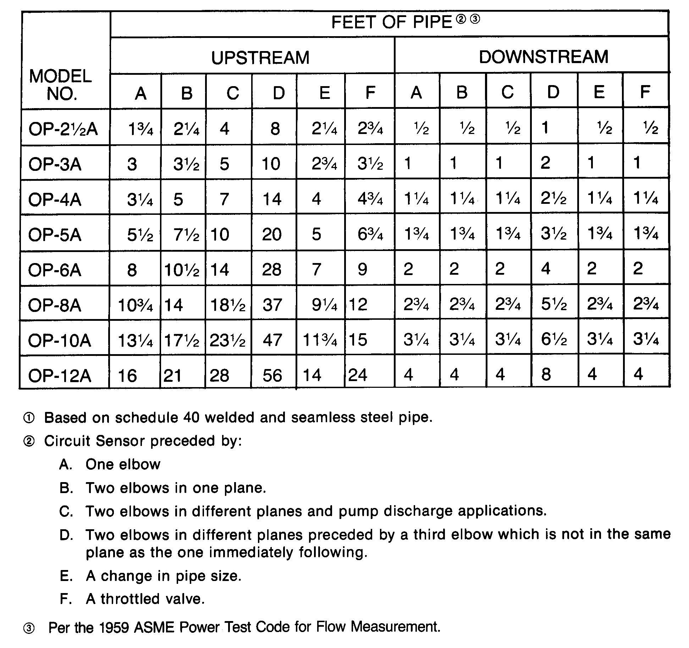
www.bellgossett.com
Bell & Gossett is a trademark of Xylem Inc. or one of its subsidiaries.
© 2016 Xylem Inc. HS-CSFM-982 September 1982

