
SPECIFICATIONS CP-526

Furnish and install pumps with capacities as shown on plans.
Pumps shall be base-mounted, single stage, end suction
design.

Pump volute shall be made of ductile iron with integrally cast
pedestal support. The impeller shall be cast bronze, enclosed
type, statically and hydraulically balanced. Impeller shall be keyed to the shaft and secured by a hex head impeller nut and washer.

Pumps shall be provided with a single inside unbalanced
mechanical shaft seal for leakless operation. A suitable
arrangement shall be provided to furnish a portion of the
pumped liquid to lubricate and cool the seal faces.

Pump shall be rated for a minimum of 175 psi working pressure. Casings shall be provided with tapped and plugged
holes for priming, vent, and drain.

Pump bearing housing shall have heavy duty regreasable
ball bearings.

Baseplate shall be channel steel, sufficiently rigid to support
the pump and driving motor.

A flexible-type coupler, capable of absorbing torsional vibration, shall be employed between the pump and motor, and it shall be equipped with a suitable coupling guard as required. Contractor to level and grout each unit according to manufacturer’s instructions.

The motor shall be NEMA specifications and shall be the
size, voltage and enclosure called for on the plans. Pump and motor shall be factory aligned, and shall be realigned by contractor after installation.

Each pump shall be factory tested. It shall then be thoroughly cleaned and painted with at least one coat
of high grade machinery enamel prior to shipment.

Each pump shall be checked by the contractor and regulated for proper differential pressure, voltage and amperage draw. This data shall be noted on a permanent tag or label and fastened to the pump for owner’s reference. Pump series shall be “Series 1510 ” as manufactured by Xylem Bell & Gossett.
Series 1510 - 8G
Centrifugal Pumps – Base Mounted

TYPICAL SPECIFICATION FOR FLEXIBLE
COUPLED END-SUCTION PUMPS

. . . . . . . . . . . . . . . . . . . . . . . . . . . . . . . . . . . . . . . . . . . . . . . . . . . . . . . . . . . . . . . . . . . . . . . . . . . . . . . . . . . . . . . . . . . . . .
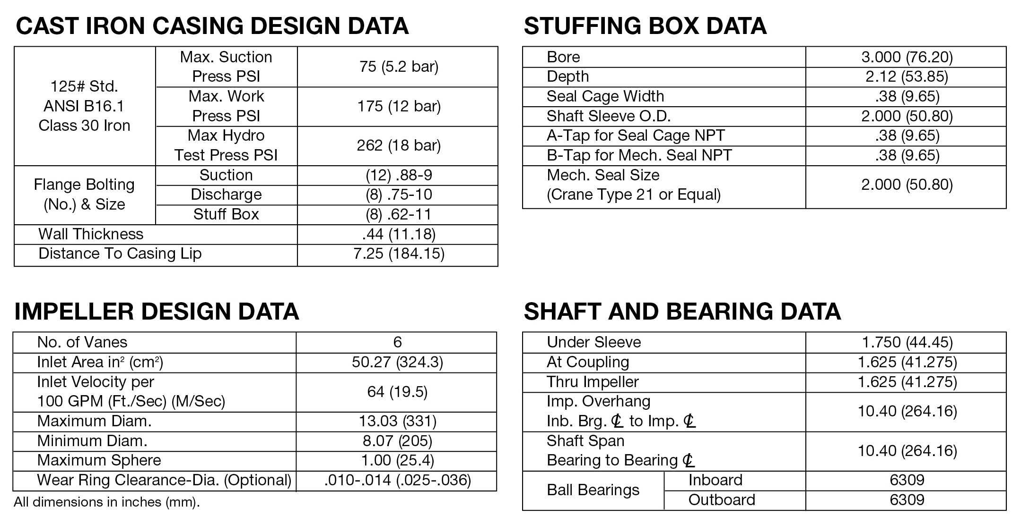
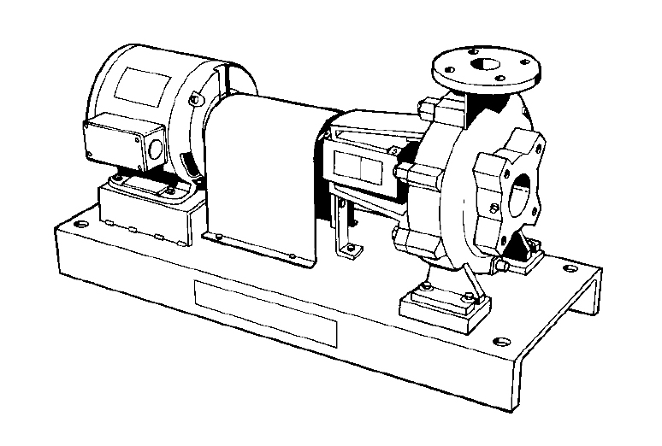

www.bellgossett.com
Bell & Gossett is a trademark of Xylem Inc. or one of its subsidiaries.
© 2015 Xylem Inc. CP-526 December 1995

